Jawaban Quiz SQL: Rahmat-Agung-Hadiwardoyo

1. Buat query untuk menampilkan employee yang memiliki gaji tertinggi dan ter-rendah. Gunakan union, min, max. (name masih berdasarkan first_name, belum digabung dengan last_name)

**Query:**

**select** employee_id,**concat**(first_name, ' ', last_name) **AS** full_name,salary

**from** employees

**where** salary = (**select** **MIN**(salary) **from** employees )

**union**

**select** employee_id, **concat**(first_name, ' ', last_name) **AS** full_name,salary

**from** employees

**where** salary = (**select** **MAX**(salary) **from** employees )

**order** **by** salary **desc**

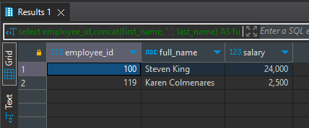**Hasil:**

1. Buat query untuk menampilkan department yang memiliki gaji tertinggi dan ter-rendah. Gunakan union, min, max.

**Query:**

**select** a.department_id,b.department_name, a.salary

**from** employees a **join** departments b

**on** a.department_id = b.department_id

**where** salary = (**select** **MIN**(salary) **from** employees )

**union**

**select** a.department_id,b.department_name, a.salary

**from** employees a **join** departments b

**on** a.department_id = b.department_id

**where** salary = (**select** **MAX**(salary) **from** employees )

**order** **by** salary **desc**

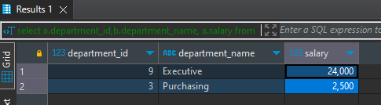**Hasil:**

1. Buat query untuk menampilkan jumlah employee berdasarkan job role nya.

**Query:**

**select** j.job_id, j.job_title, **count**(*) **as** total_employee

**from** jobs j **join** employees e

**on** j.job_id = e.job_id

**group** **by** j.job_id

**order** **by** j.job_id

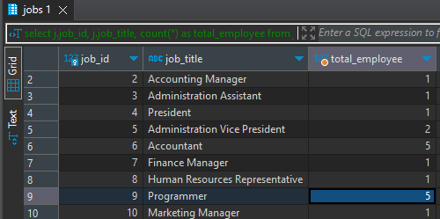**Hasil:**

1. Buat query untuk menampilkan Total employee tiap department dan jobs yang totalnya melebihi dari 3 orang.

**Query:**

**select** d.department_id, d.department_name, j.job_id, j.job_title, **count**(e.employee_id) **as** total_employee

**from** employees e **join** departments d

**on** d.department_id = e.department_id **join** jobs j

**on** e.job_id = j.job_id

**group** **by** d.department_id, j.job_id

**having** **count**(e.employee_id) >3

**order** **by** total_employee **desc**

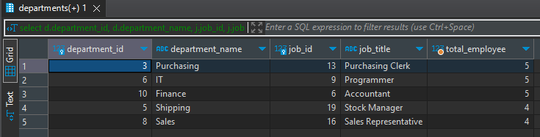**Hasil:**

1. Buat query untuk menampilkan employee yang memiliki masa kerja <= 25 tahun. Gunakan function age & extract.

**Query:**

**select** first_name, last_name, **concat**(first_name, ' ', last_name) **as** full_name,hire_date , **age**(**now**(), hire_date ) **as** "working period"

**from** employees

**where** **age**(**now**(), hire_date ) <= '25 years'

**order** **by** hire_date **desc**

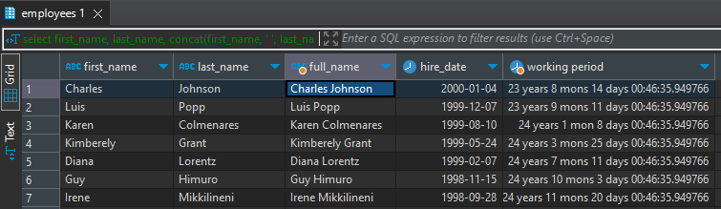**Hasil:**

1. Buat script update untuk menaikan gaji pegawai yang masa kerjanya <=25 tahun, naikan gaji sekarang + 100, dan tampilkan.

**Query:**

**update** employees **set** salary = salary + 100 **where** **age**(**now**(),hire_date) >= '25 years'

**select** **concat**(first_name, ' ', last_name) **as** full_name,hire_date , salary , **age**(**now**(), hire_date ) **as** "working period"

**from** employees

**order** **by** **age**(**now**(), hire_date )

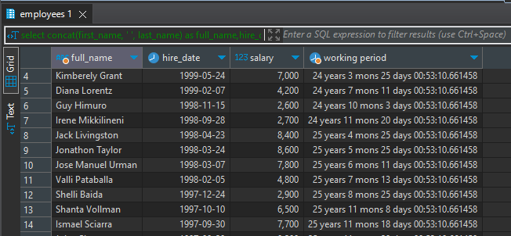**Hasil:**

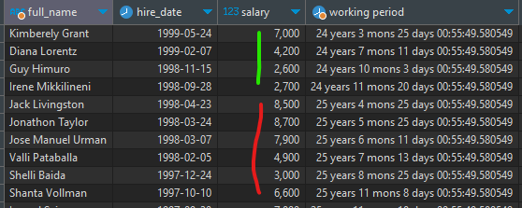

1. Buat script update untuk memindahkan department yang jumlah pegawai nya 1 orang, dipindahkan ke department Sales, kecuali department HRD.

**Query:**

**update** employees e

**set** department_id = ( **select** department_id **from** departments **where** department_name ='Sales')

**where** e.department_id **IN** (

**SELECT** d.department_id **FROM** departments d

**JOIN** employees e **ON** d.department_id = e.department_id

**GROUP** **BY** d.department_id

**HAVING** **COUNT**(e.department_id) = 1

) **and** e.department_id !=4

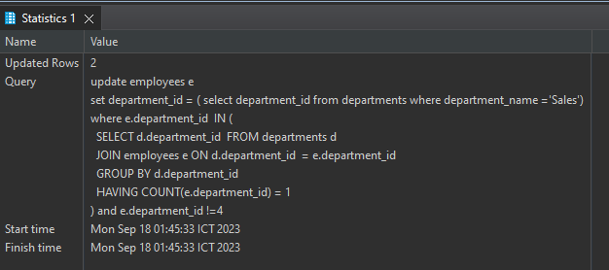**Hasil:**

